Excelerate Outreach Performance Dashboard Report
Response, Conversion, and Engagement Analysis
SLU 0112 – DVT Team 19

1. Introduction
This report presents a detailed analysis of outreach performance using the Excelerate Outreach Performance Dashboard. The objective of the analysis is to evaluate outreach effectiveness, identify engagement patterns, highlight gaps in the data, and provide actionable insights aligned with Excelerate’s enrollment improvement goals. All findings in this report are derived strictly from the dashboard visuals and the exploratory data analysis conducted on the provided dataset.

2. Dataset Overview and Scope
The dataset presents outreach activity across multiple campaigns, countries, time periods, and contact attempts. Key variables include outreach attempts, connection outcomes, response rates, enrollment outcomes, time of contact, attempt count per applicant, and country-level performance indicators. The analysis focuses on outreach volume, response behavior, and conversion outcomes rather than individual applicant profiling.

3. Outreach Trends Over Time

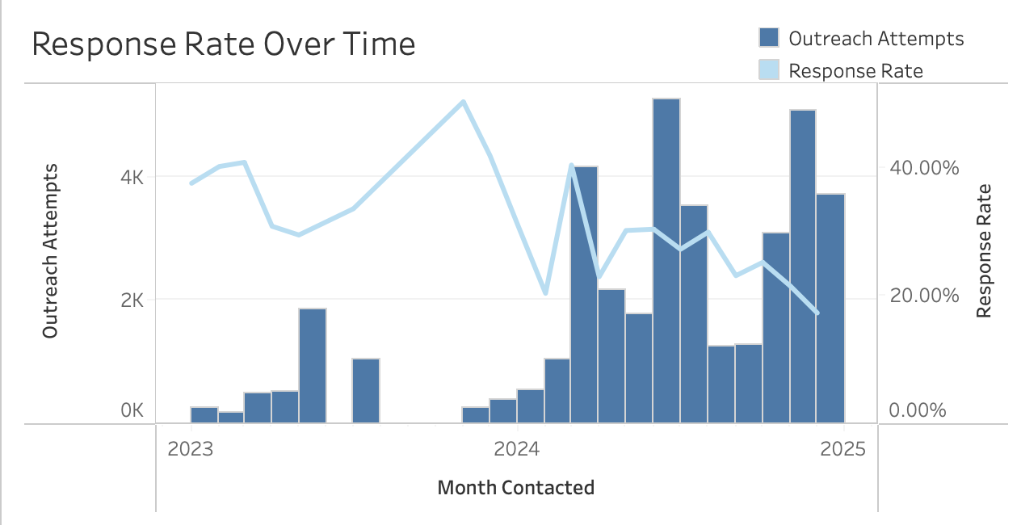
The outreach trend analysis shows a clear increase in outreach volume over time, particularly from 2024. Earlier periods reflect relatively low outreach activity, followed by sustained growth in monthly outreach attempts. Despite higher outreach volume in later months, response rates fluctuate rather than increasing proportionally. This indicates that increasing volume alone does not guarantee improved engagement outcomes. Periods of peak outreach sometimes coincide with declining response rates, suggesting diminishing returns at higher volumes. As evidenced by declining response rates. Some of our highest-volume months actually correspond with declining response rates, which tells us we're hitting diminishing returns. More outreach doesn't automatically mean better results.

4. Campaign Effectiveness Metrics

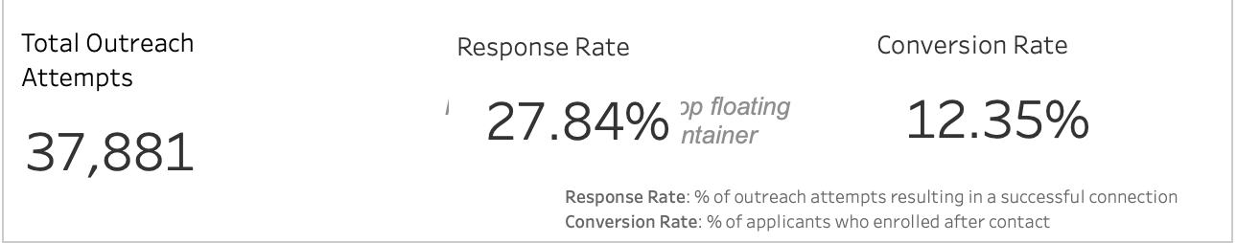
The overall response rate across all outreach activity is approximately 27.84 %, indicating that just over one-quarter of outreach attempts resulted in a successful connection. The overall conversion rate is approximately 12.35% at the applicant level. This drop from response to conversion highlights a significant gap between initial engagement and final enrollment outcomes. Additionally, the presence of invalid and null values within conversion-related fields suggests data quality limitations that may affect the reliability of conversion analysis for certain regions or campaigns.

5. Time-of-Day Performance Analysis

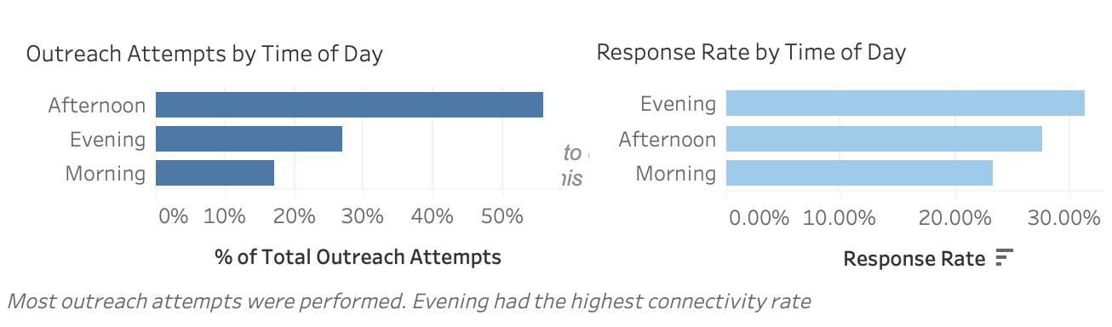
Outreach attempts are most frequently conducted during the afternoon, followed by evening and then morning. However, response rates are highest during the evening, indicating that evening outreach is more effective despite lower volume compared to afternoon outreach. Morning outreach consistently shows the lowest response rate. This misalignment between outreach volume and response effectiveness suggests an opportunity to shift outreach efforts toward time windows that yield higher engagement.

6. Contact Attempt Patterns
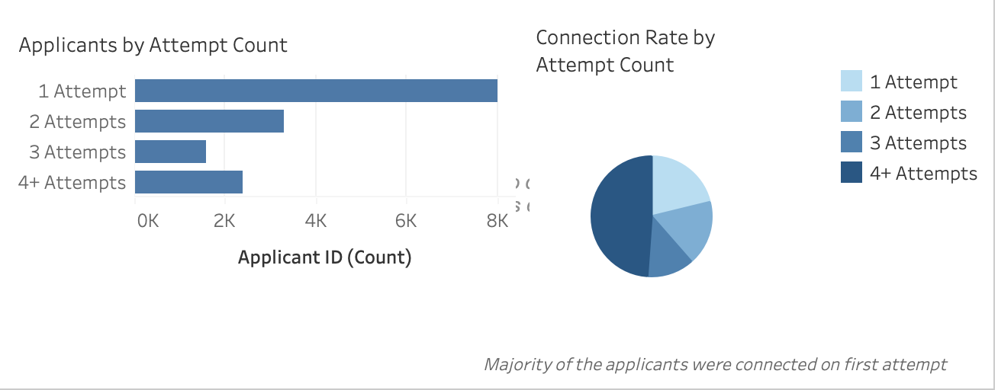
The majority of applicants are contacted successfully on the first attempt, both in absolute count and connection rate. Connection rates decline steadily as the number of attempts increases, with fourth and subsequent attempts yielding the lowest success. This pattern indicates that early engagement is critical and that repeated follow-ups offer diminishing returns. While follow-up attempts remain necessary, excessive attempts may not be an efficient use of outreach resources.

7. Geographic Performance Analysis

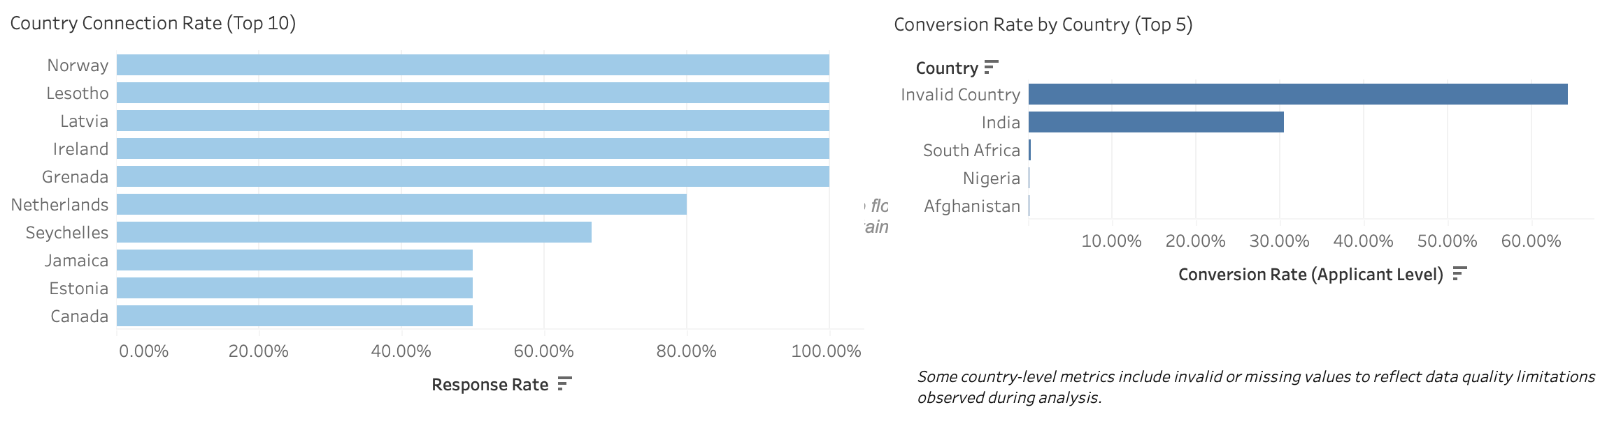
Connection and conversion rates vary quite a bit by country. Some regions are clearly more responsive than others. The conversion analysis includes invalid and missing country entries, which was left visible because they reflect a real problem with the data quality.
These gaps (whether from incomplete data entry or inconsistent tagging) limit how confidently conclusions can be drawn about certain markets. Despite these limitations, the country-level view helps identify markets where outreach engagement is comparatively stronger.

8. Data Quality Gaps and Limitations
The analysis identifies several data quality challenges, particularly within conversion-related fields. Invalid and null country entries appear prominently in conversion rate visuals, limiting interpretability. These gaps may result from incomplete data entry, inconsistent country tagging, or enrollment tracking issues. While these limitations do not invalidate the analysis, they highlight areas where data governance improvements would significantly enhance future outreach reporting and decision-making.

9. Insights and Recommendations
Key Insights:
- Outreach volume has increased substantially over time, but response rates do not scale proportionally.
- Evening outreach yields the highest response rate despite lower outreach volume than afternoon periods.
- First contact attempts are the most effective, with diminishing returns on subsequent attempts.
- Conversion rates are significantly lower than response rates, indicating funnel drop-off after initial engagement.
- Data quality issues, particularly invalid and missing country values, constrain conversion analysis.
Recommendations:
- Reallocate outreach efforts toward evening time windows to maximize response effectiveness.
- Prioritize first-contact quality and preparedness to improve early engagement success.
- Review follow-up strategies to balance persistence with efficiency, reducing low-impact repeat attempts.
- Strengthen data validation processes for country and enrollment fields to improve conversion tracking.
- Use response and conversion metrics together when evaluating campaign performance, rather than volume alone.

10. Conclusion
The Excelerate Outreach Performance Dashboard provides clear evidence that effectiveness depends on timing, attempt strategy, and data quality rather than outreach volume alone. By aligning outreach execution with observed engagement patterns and addressing identified data gaps, Excelerate can improve enrollment outcomes and optimize the use of outreach resources.

